- Purpose
  - The purpose of this document is to describe the procedure for assembling a Crewman low speed floor machine.
- Scope
  - This SOP applies to all equipment assembly team members. The process applies to the following machine ID’s:
E083013EQM0600BE1200 – Crewman 17HD Heavy Duty Floor Machine
E083013EQM0607BE1200 – Crewman 17HD Heavy Duty Floor Machine-Canada
E083014EQM0600BE1200 – Crewman 20HD Heavy Duty Floor Machine
E083014EQM0600BE1200 – Crewman 20HD Heavy Duty Floor Machine-Canada
- Responsibilities
  - The operations manager/supervisor is responsible for enforcing this SOP.
- Materials
  - The proper materials needed for this process are listed on the machine work order.
  - Hand/Power Tools
- Definitions

- Procedure
  - Start by placing the proper base into the drill fixture as shown. If a 17HD is being built, use 81127, and if a 20HD is being built, use 81129.

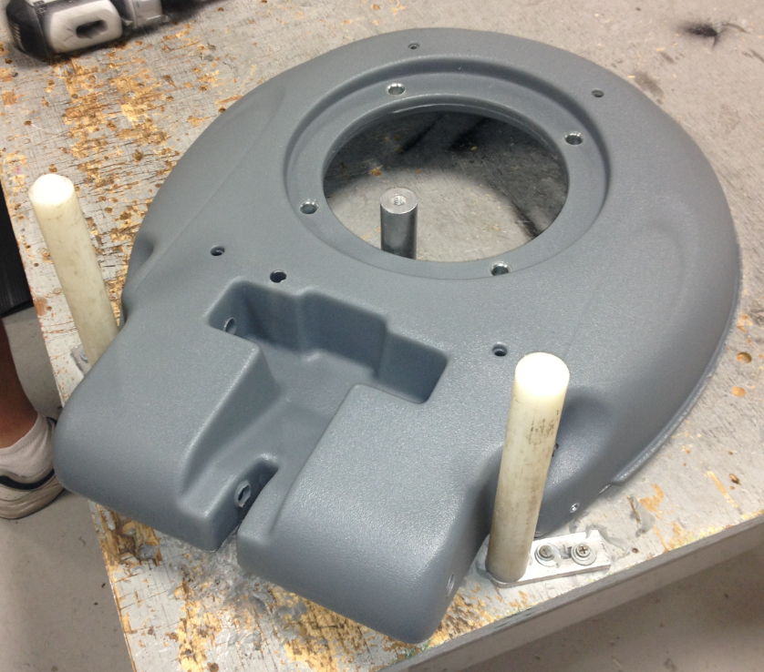

  - Use the long ½” drill bit provided and drill out the two holes in the base that the axles go through.

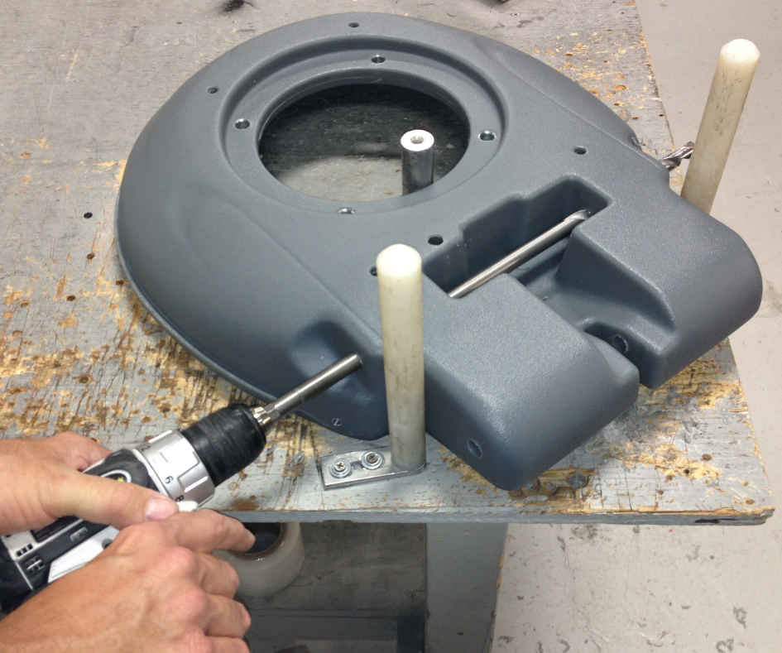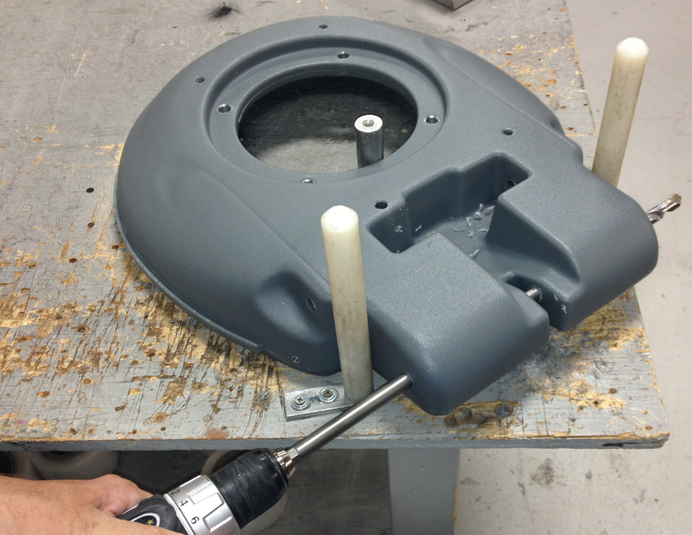

  - Use the ½” reamer provided and run it through the slot shown. Drilling the cross hole creates a burr in the slot that needs to be removed. Move the reamer back and forth until the burr has been cleared.

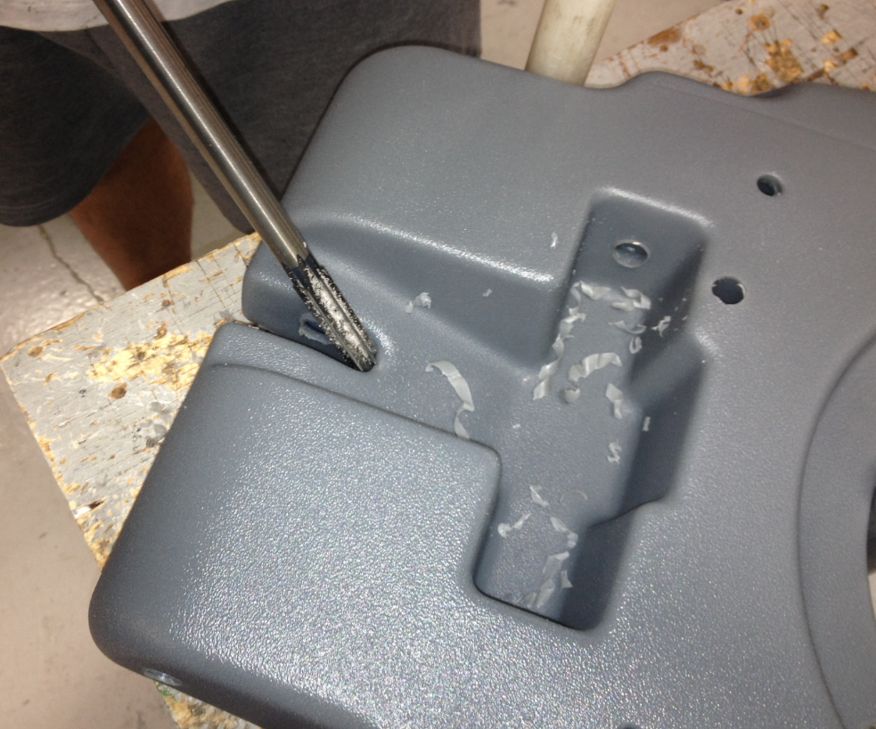

  - Place a motor (84570) onto the table as shown. Orient the capacitors and the cord towards the edge of the table as shown.

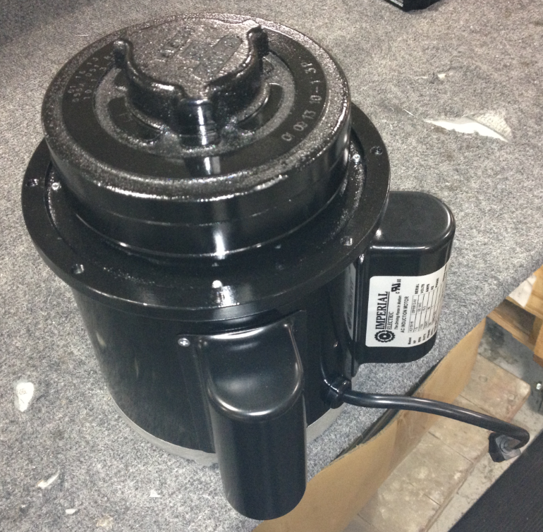

  - Place the drilled out base onto the motor in the orientation shown. This will keep the capacitors and the cord on the motor towards the rear of the machine.

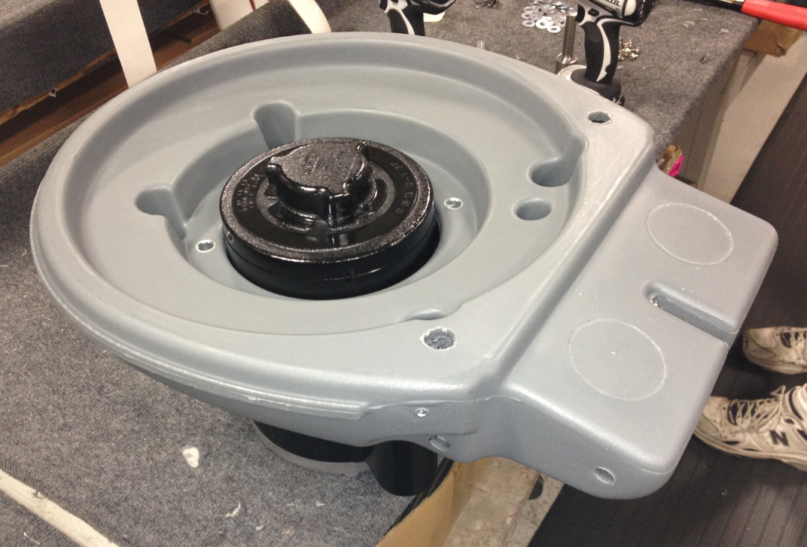

  - Bolt the machine base to the motor using 4 bolts (83641), 4 lock washers (81067), and 4 flat washers (81062). Put some blue loc-tite onto the threads before installing.

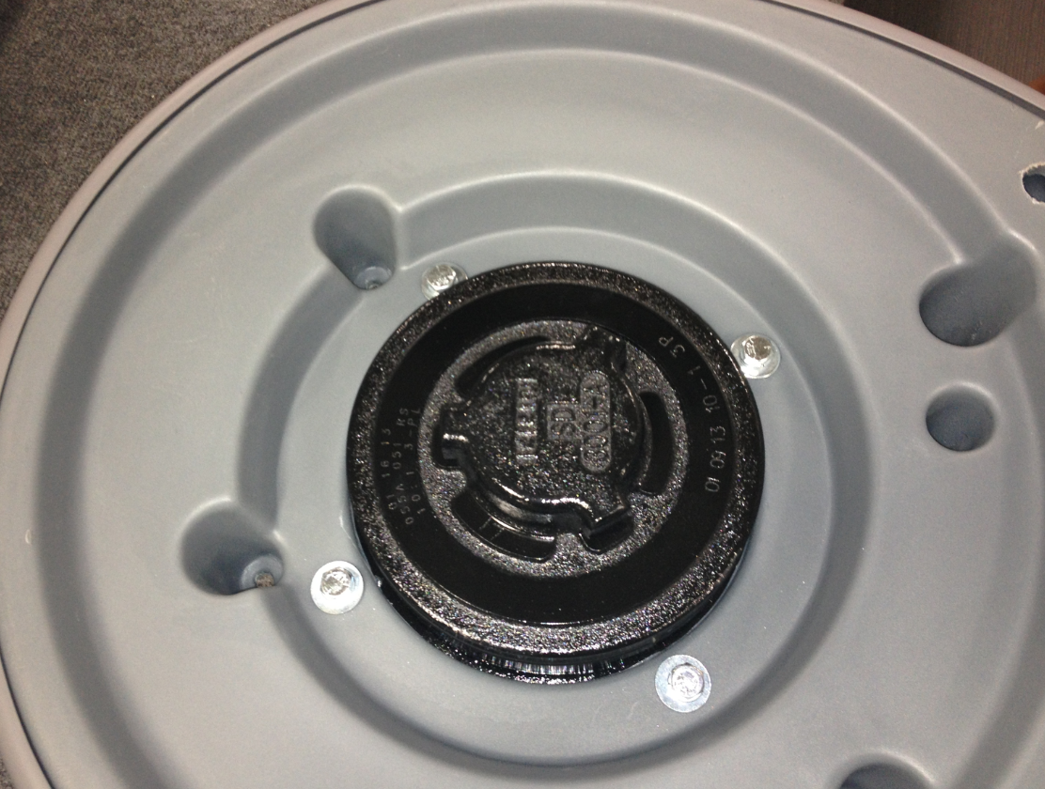

  - Install the bumper (83141) as shown using a bolt (83425) and a washer (81068) on each end. Install the bolts and then stretch the bumper of the front of the base as shown. Be sure that it properly snaps into place.

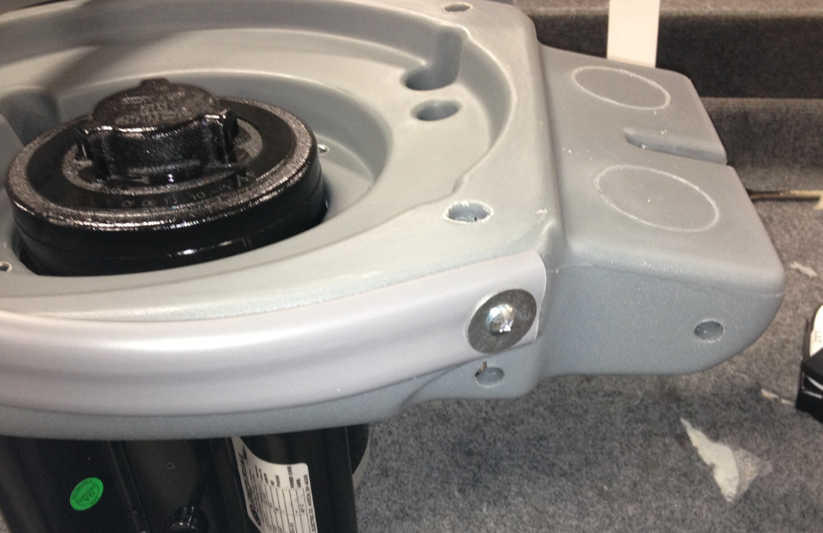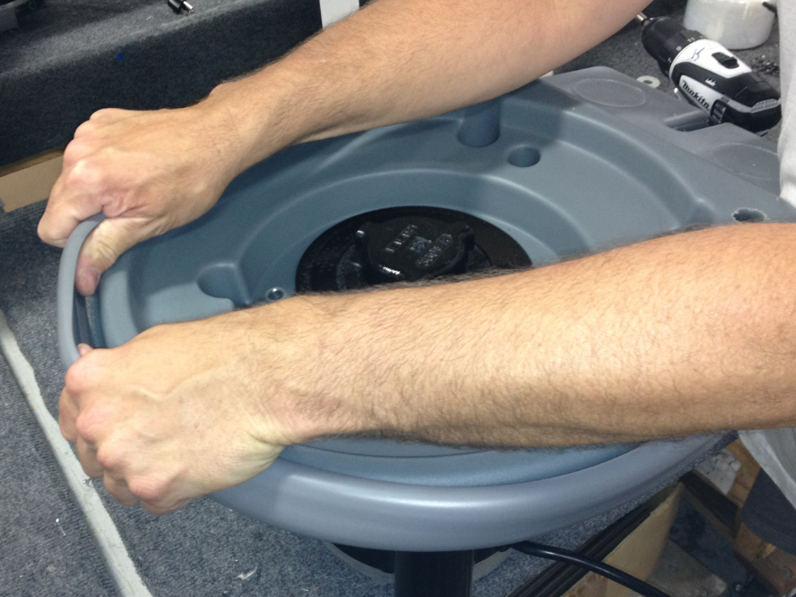

  - Use a hand drill to install the rear axle (83379) into the hole shown. Only install the axle ½ way at this point.

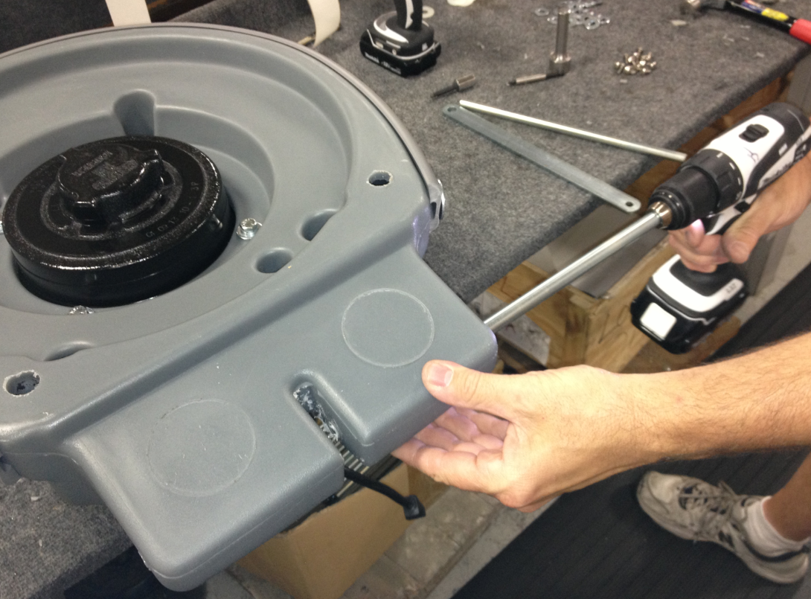

  - In the middle slot in the base, place a flat handle bracket (83136) sandwiched between 2 nylon washers (83145). Once these are in place, continue installing the axle through them and out the other side of the base.

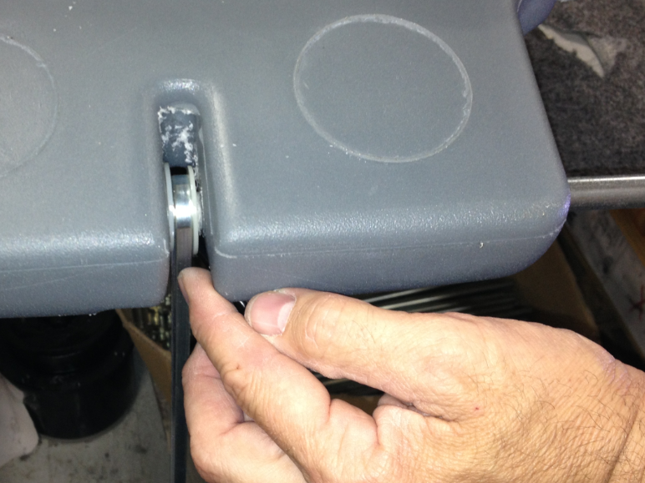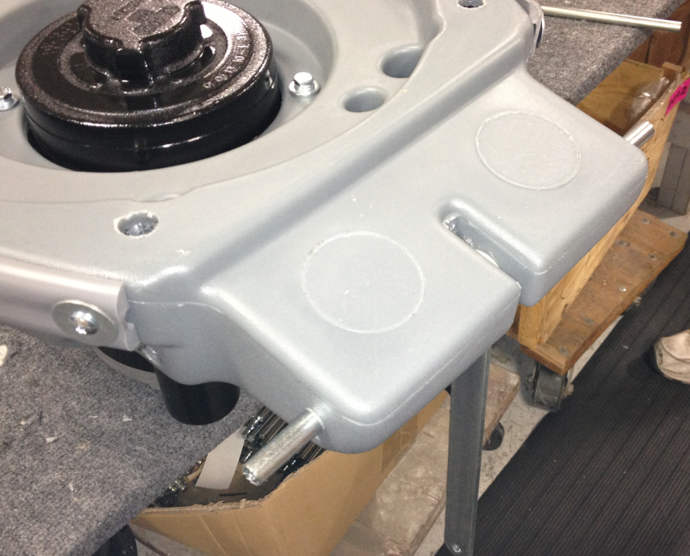
Bracket
Washer
Washer

  - Place a wave washer (83269) onto each end of the axle as shown (2 total). Once that is complete, place a nylon washer (83145) onto each end of the axle as shown (2 total).

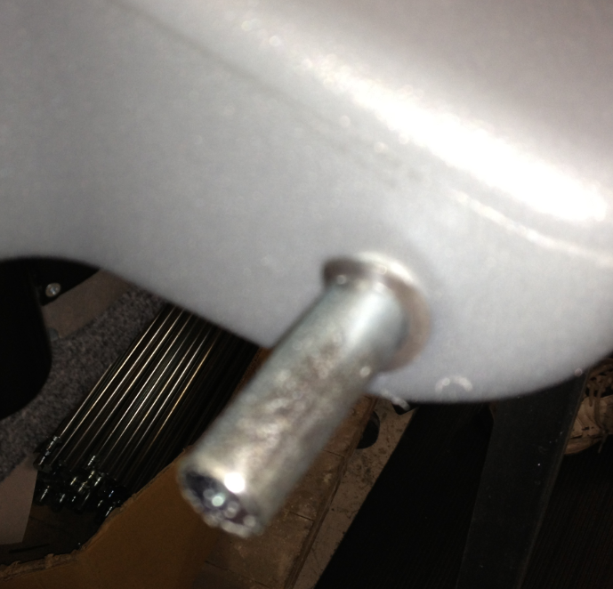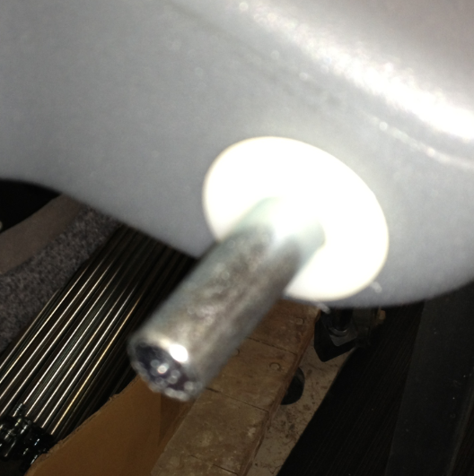

  - Place a 5” wheel (81124) onto each end of the axle as shown.

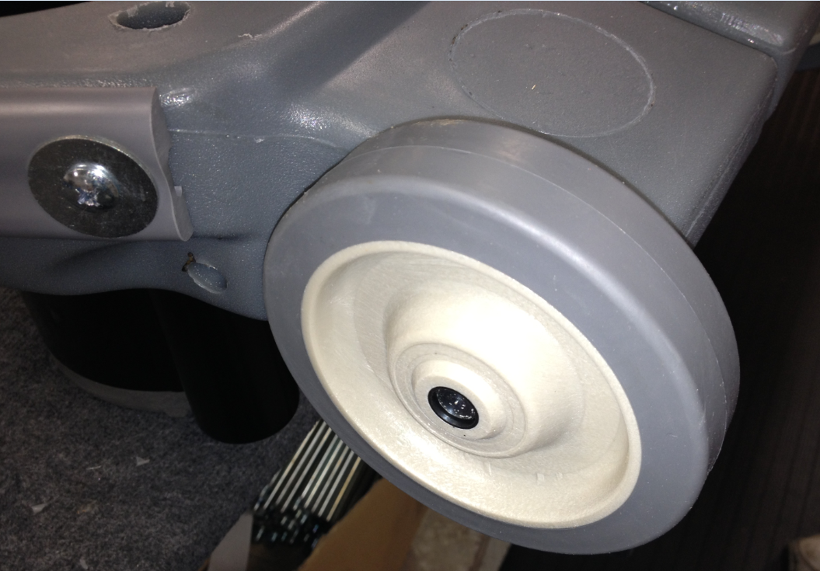

  - Use the installation tool provided and hammer an axle cap (83143) onto each end of the axle. This will hold everything on.

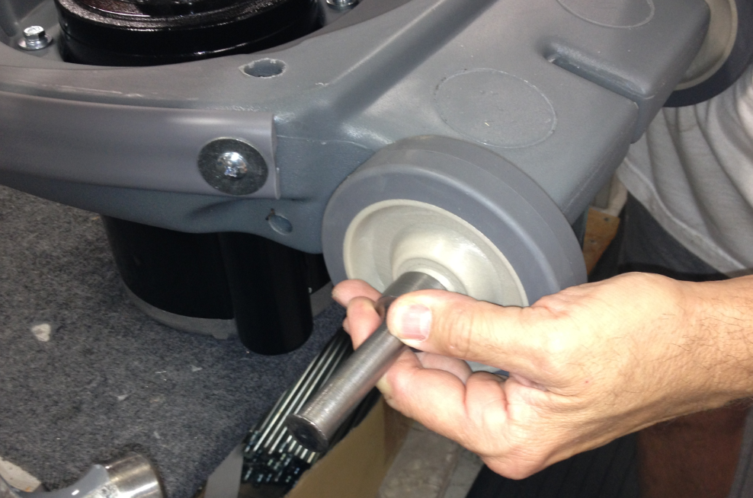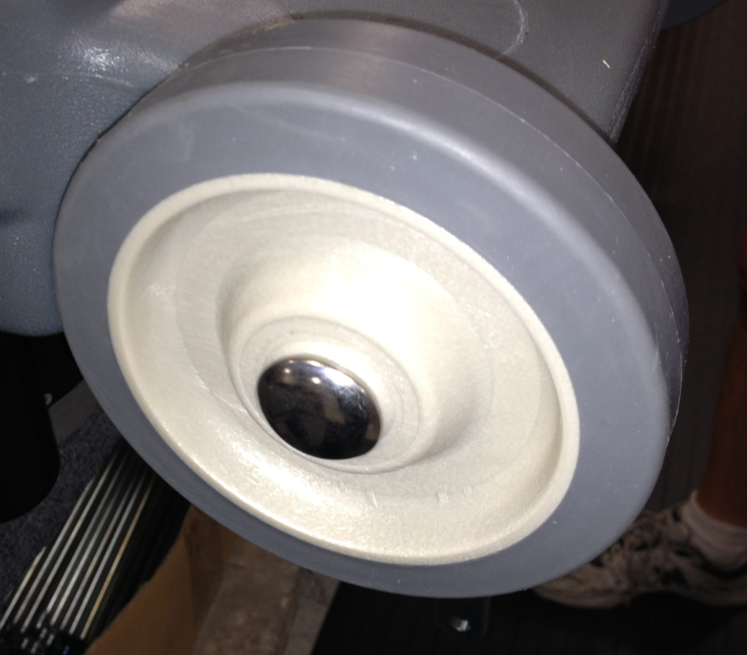

  - Take a roll of plastic wrap and wrap the wheels. This will keep them clean until the customer receives the machine.

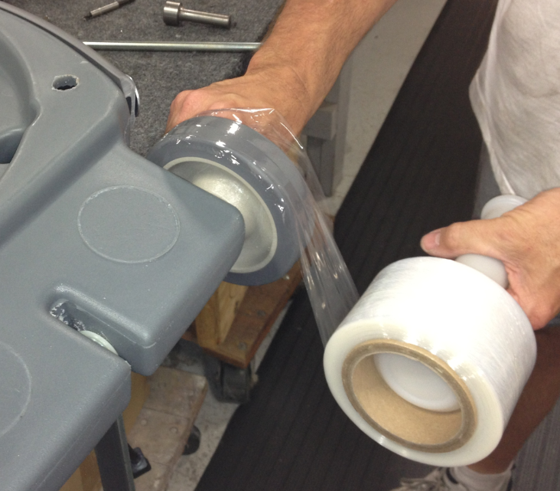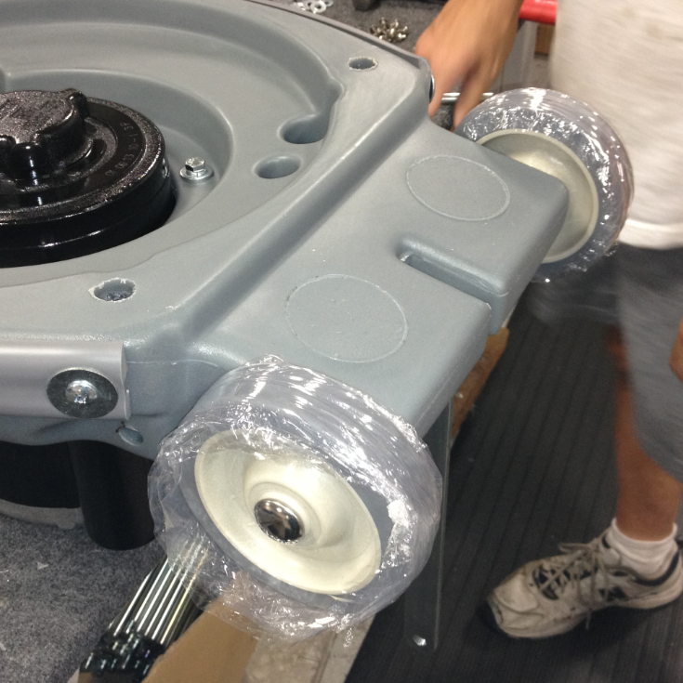

  - Flip the machine base over so that the motor is on top.

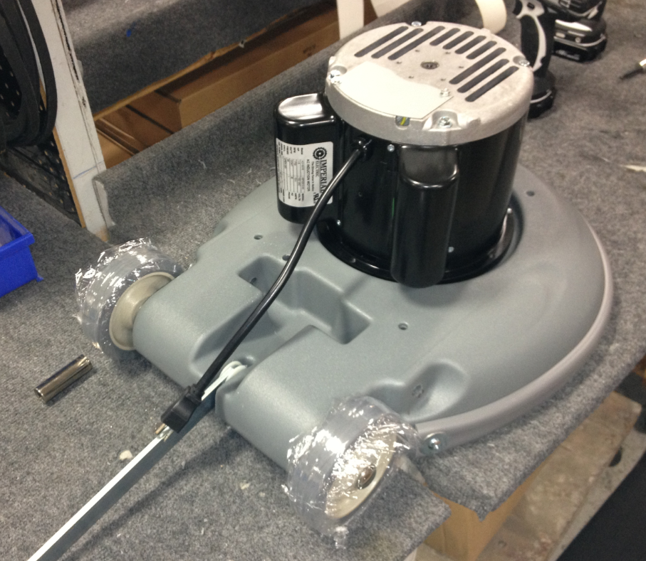
  - Insert a plastic ratchet plug (81071) into each of the 4 holes spaced around the motor.

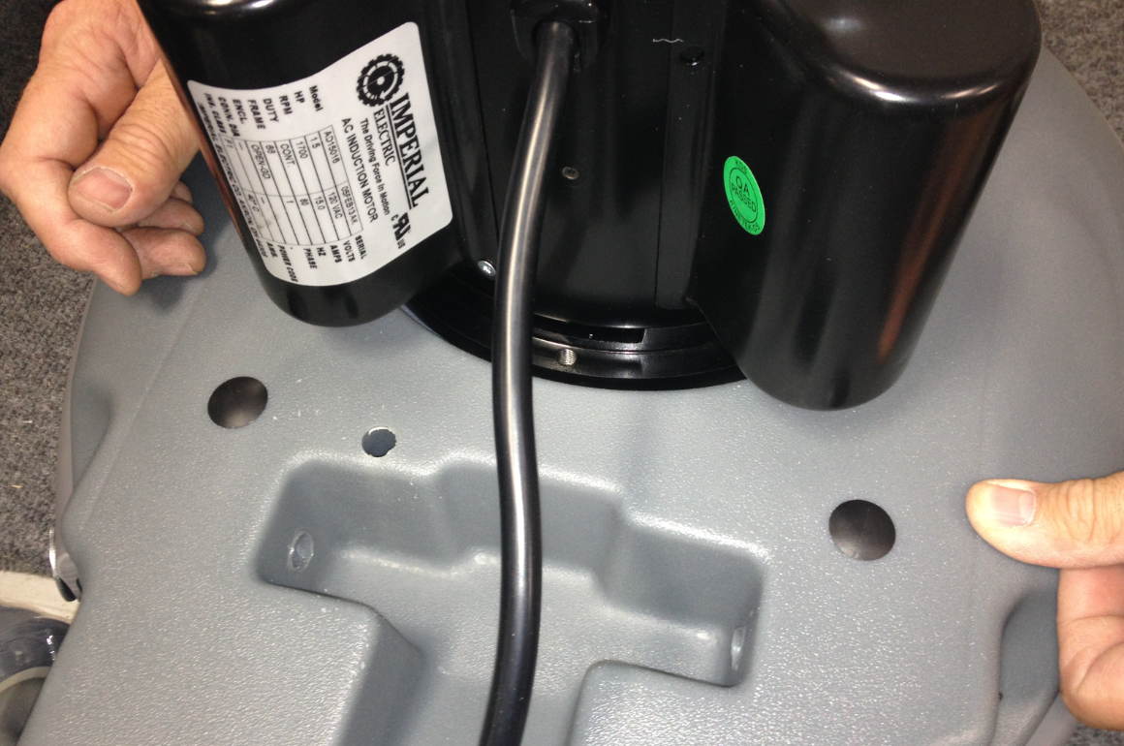

  - Put a motor cover (81140) onto the top of the motor as shown. Bolt it into place using 3 bolts (81526).

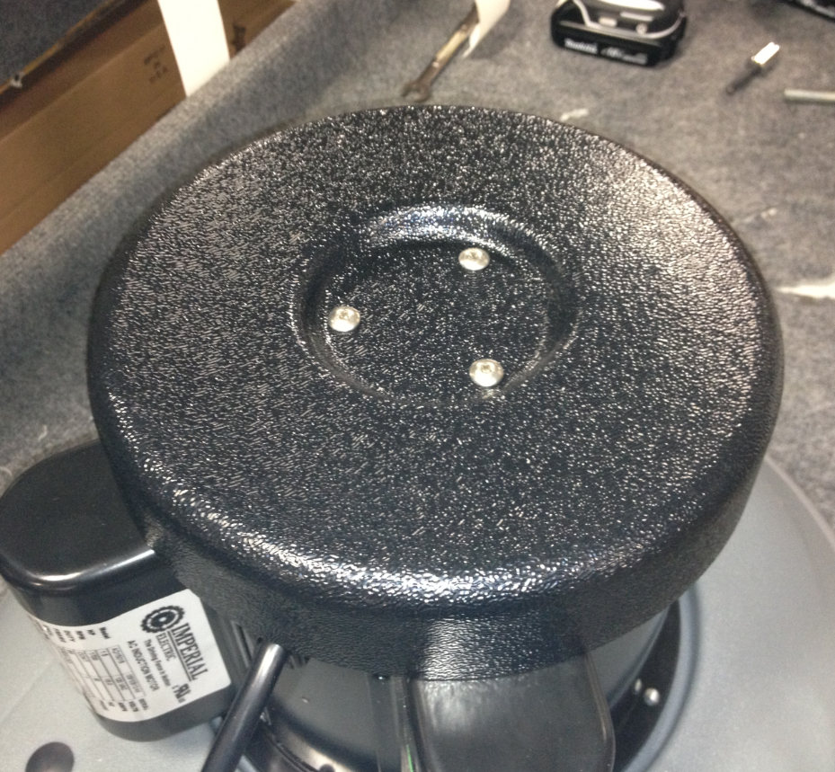

  - Place a Betco Equipment Decal (83773) onto the front of the motor as shown.

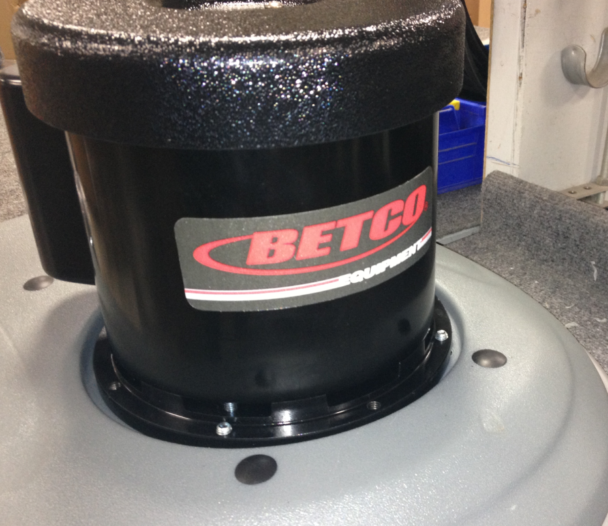

  - Take an axle (83452) and install it partially into the base. Stop when it gets to the cavity in the middle of the base.

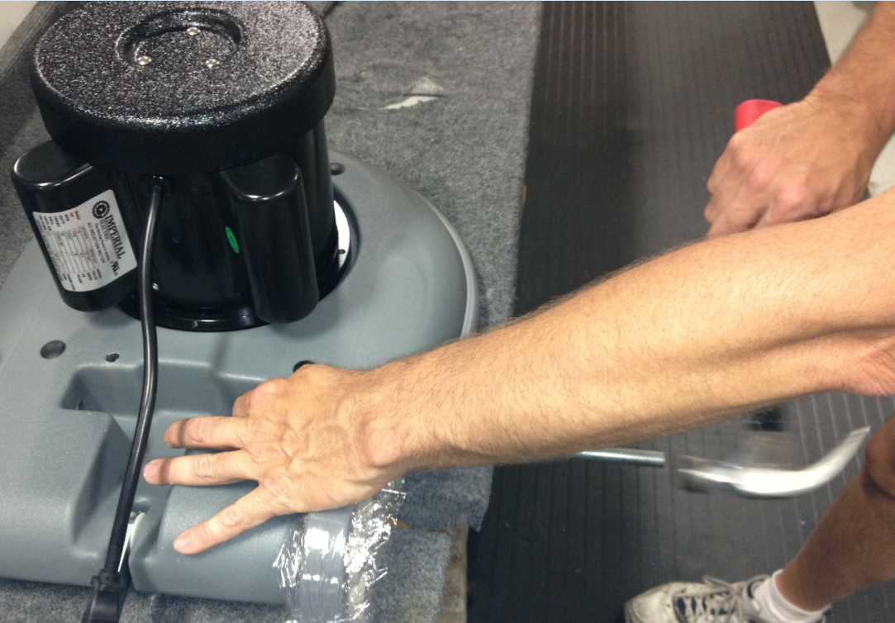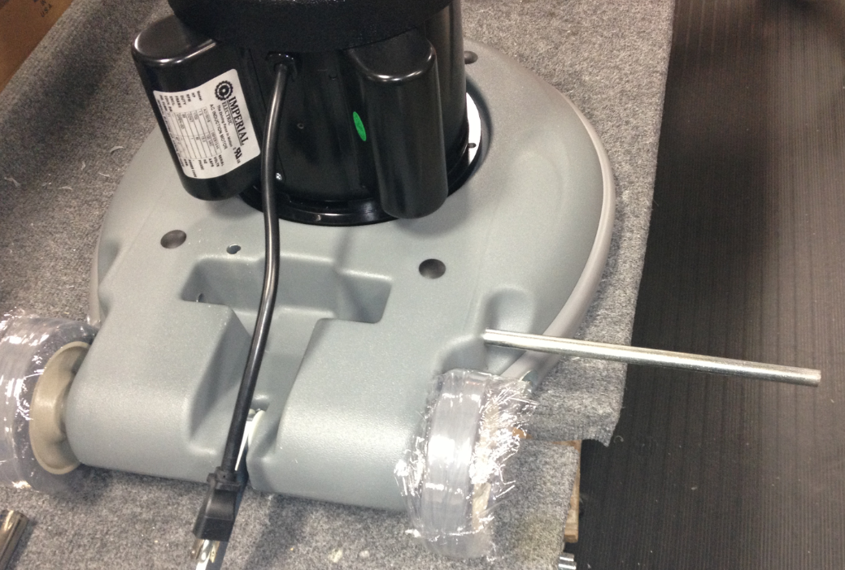

  - Assemble the handle for the machine. For assembly instructions, refer to SOP EQ 022.

  - Place the T-attachment end of the handle into the groove in the base. Install the shaft through the base and through the T-attachment. This will hold the handle in place.

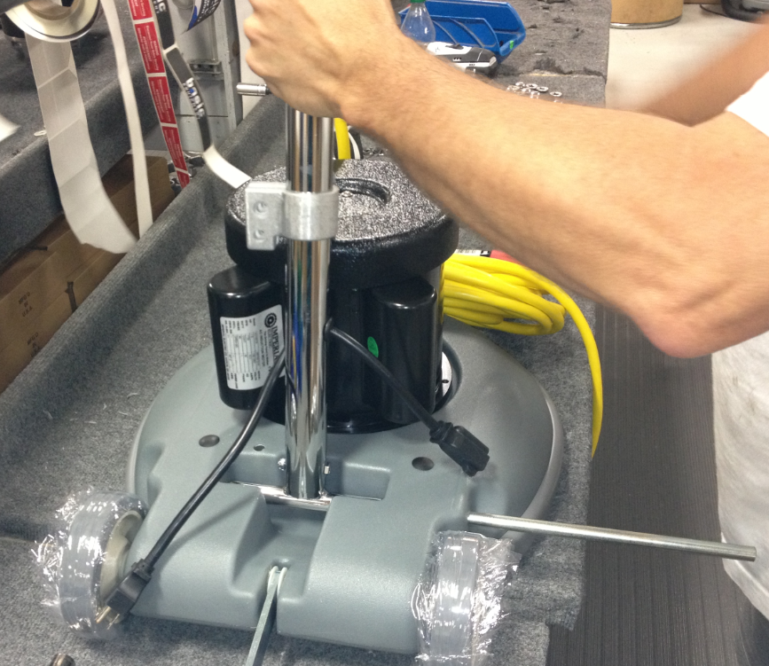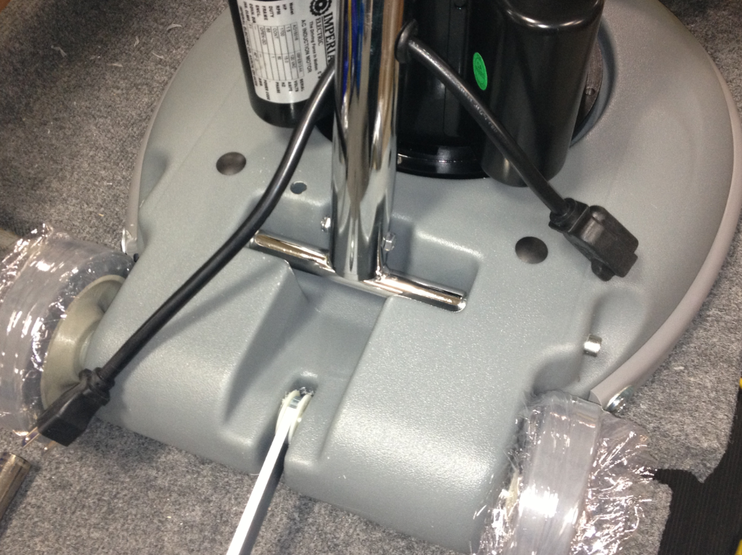

  - Once the handle is installed and centered. Install an axle cap (83143) on each end of the shaft.

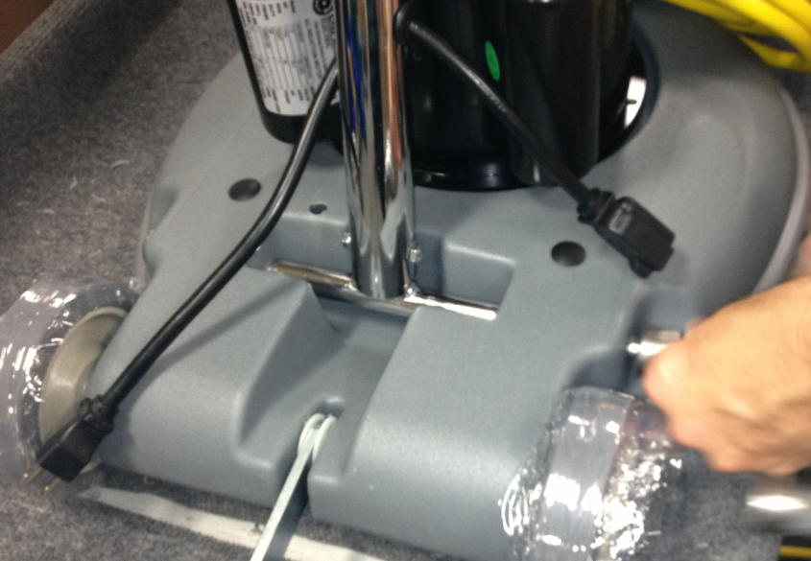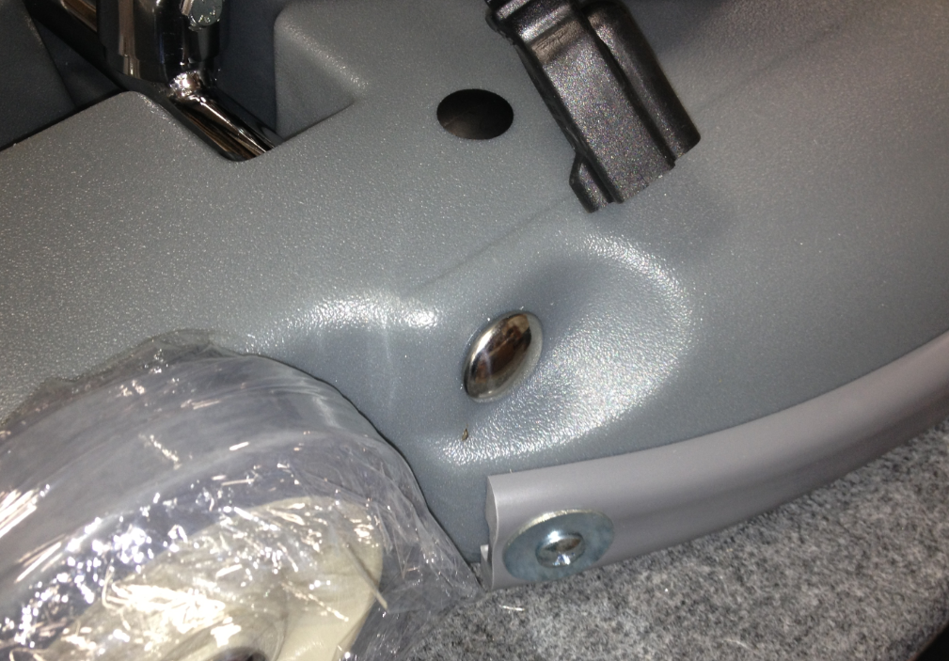

  - Secure the strut to the cord wrap using a shoulder bolt (81077) and a nut (81063).

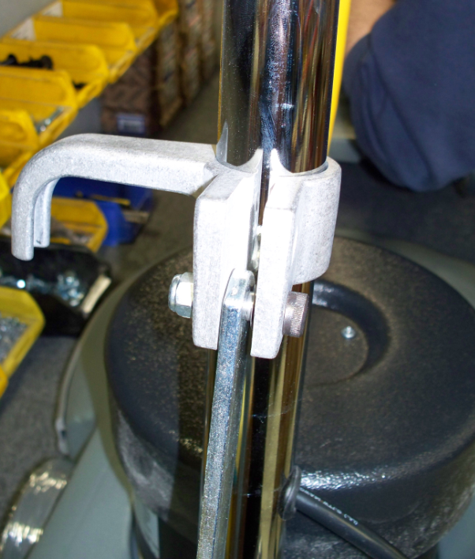
Bolt
Nut

  - Assemble the cam handle using the following components: 1 cam handle (83133), 1 oval washer (83135), 3 nylon washers (83145), and 1 nut (81063). The oval washer presses onto the similar profile on the stem of the cam handle. Note the order of the parts below.
Spring Washer
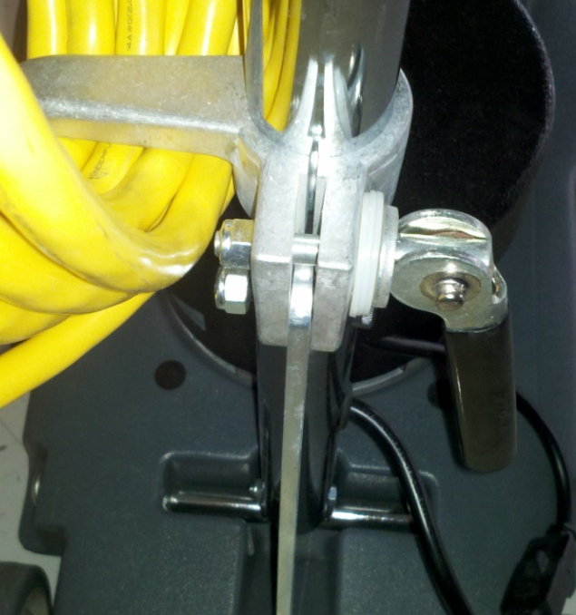
Nut
Cam Handle
Nylon Washers

  - Tighten the nut enough so that the cord hook slides easily up and down the handle shaft when the cam is released and holds the base and handle tight when the cam is engaged.
  - Plug the cord from the motor into the cord coming from the handle.

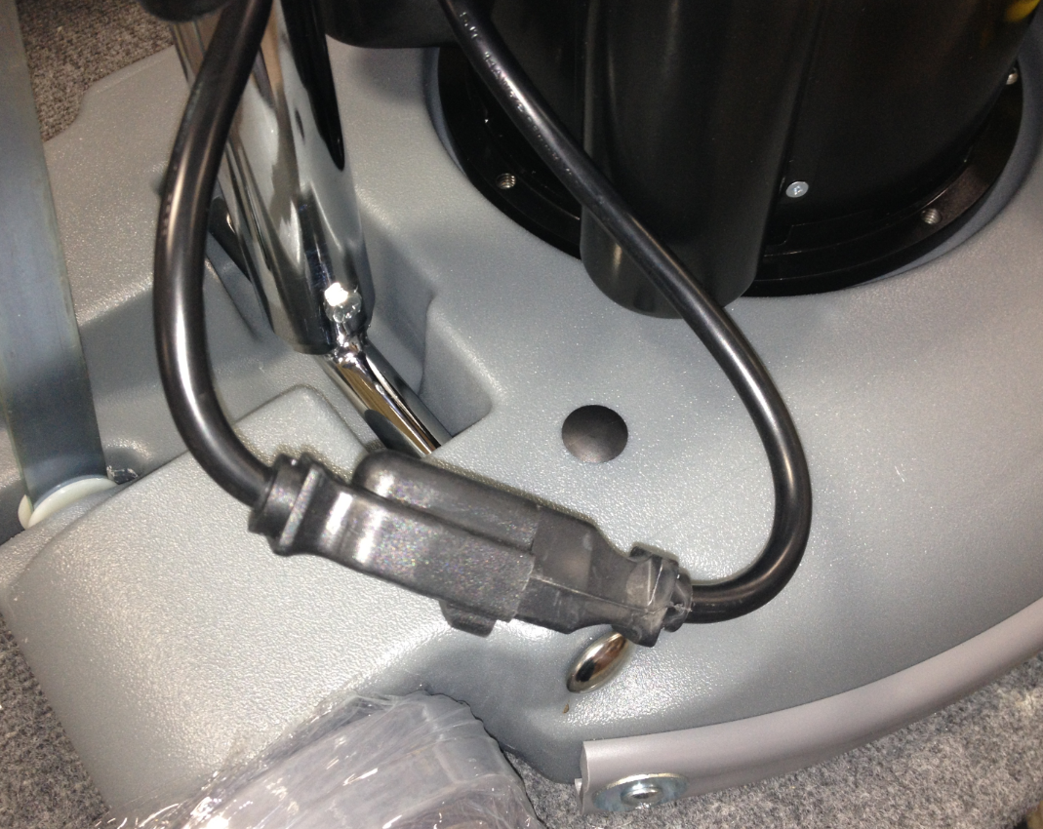

  - Put the the appropriate decal on the front of the handle to designate the type of machine it is. Use 83758 for a Crewman 17HD and use 83723 for a Crewman 20HD.

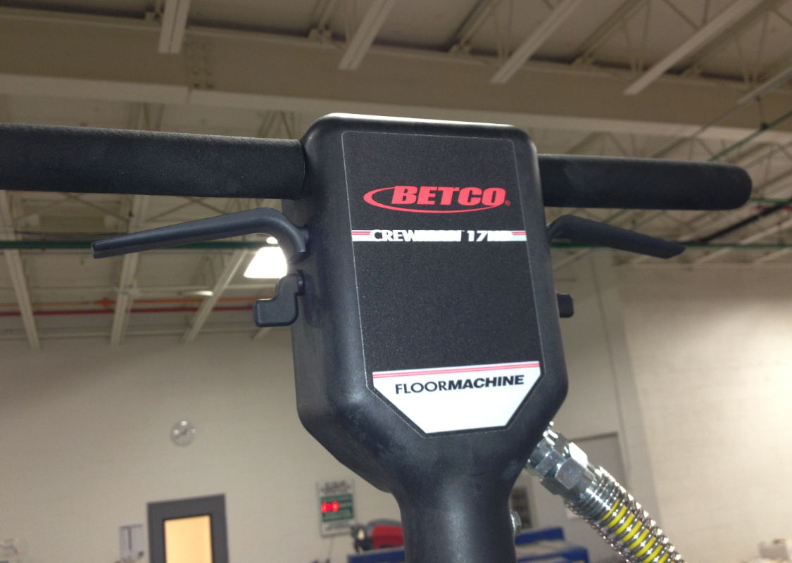

  - If the machine is to be certified for sales into Canada (E083013EQM0607BE1200 and E083014EQM0607BE1200) place a Canadian electrical warning decal onto the back side of the motor cover facing the operator.
  - The machine assembly is now complete and ready for testing.

- References (optional section as needed)

- Training Guide

Functional Training Groups Requiring Training
Equipment Group

- SOP Change Control

Date of Change | Reason for Change
Rev 01 - 11/22/2013 | This is the first version of the S.O.P. hence there are no revisions to this document.
Rev 02 - 12/7/2017 | Updated for various hardware changes and added Responsibilities section.
Rev 03 - 5/15/2019 | Changed the quantity of 83145 on the cam handle from 1 to 3. jb
Rev 04 - 3/14/2025 | Updated formatting and removed work center notes

Approvals

Submitter/AuthorApproval: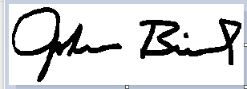Date:___5/15/2019__________________

Management Approval: Date:_____5/15/2019_________________

QAU Approval:  Date:______5/15/2019________________

